Spin Texture Monte Carlo Simulation and Classification.
Project Source
Data set generated by Monte Carlo simulations of spin configurations under different conditions.
Algorithms and related physics learned from online resources.
Background
This project is related to 2D spin texture classification and phase diagram plotting, which is related my group’s research regarding magnetic thin films. The classifier might be be able to automatically classify the simulation results and generate phase diagrams without human involvement.
Objectives/Goals
- Learn and use Monte Carlo Metropolis algorithm to generate spin structures at different temperatures and external magnetic fields. Then these graphs will be manually classified into skyrmions, spiral, paramagnetic and ferromagnetic structures. Here is one of my . It’s the z components of I need to refine the model. | 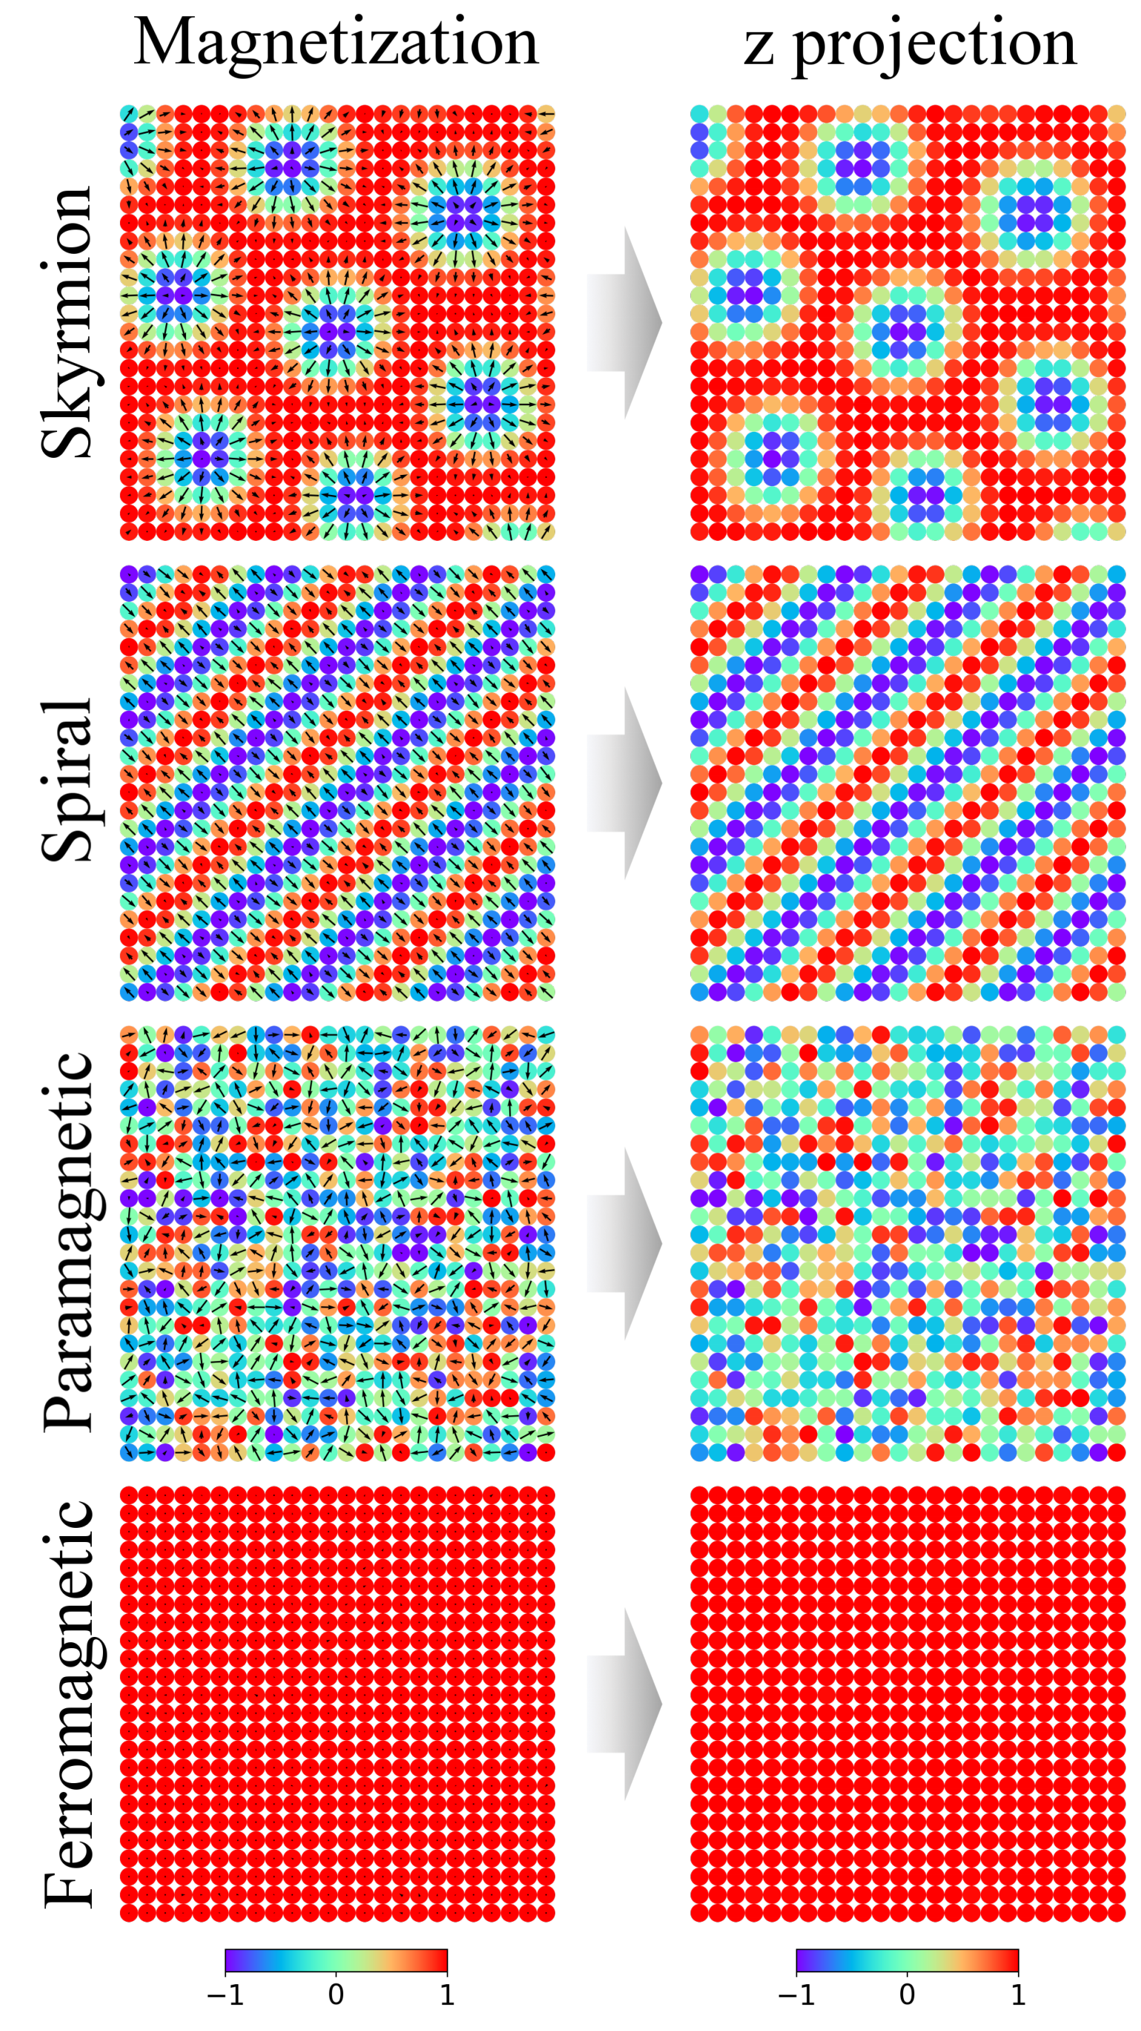  Ideal results
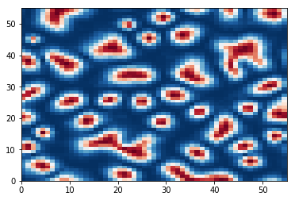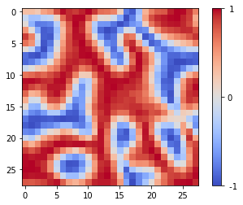
Some of the preliminary simulation results
(I haven’t delved deep yet.)
- Train a convolutional neural network on these datasets so it can classify different spin textures..
- Use a support vector machine to decide the boundaries between different phases.

Proposed Time frame
Description of Work | Start Date | End Date
Research on problem/previous approaches | March 7, 2019
Obtain Data | March 16, 2019
Visualize/Explore data | March 23, 2019
Mid-project Checklist Due | March 28, 2019
Begin Model Testing | March 28, 2019
Fine-tune Model | April 10, 2019
Prepare Poster | April 15, 2019
Project Due | April 22, 2019

Signatures
Jason Guo
[Student Name] |  | [Signature]

[Instructor Name] |  | [Signature]

